BER curves of MIMO chain

# Full MIMO chain without encoder:

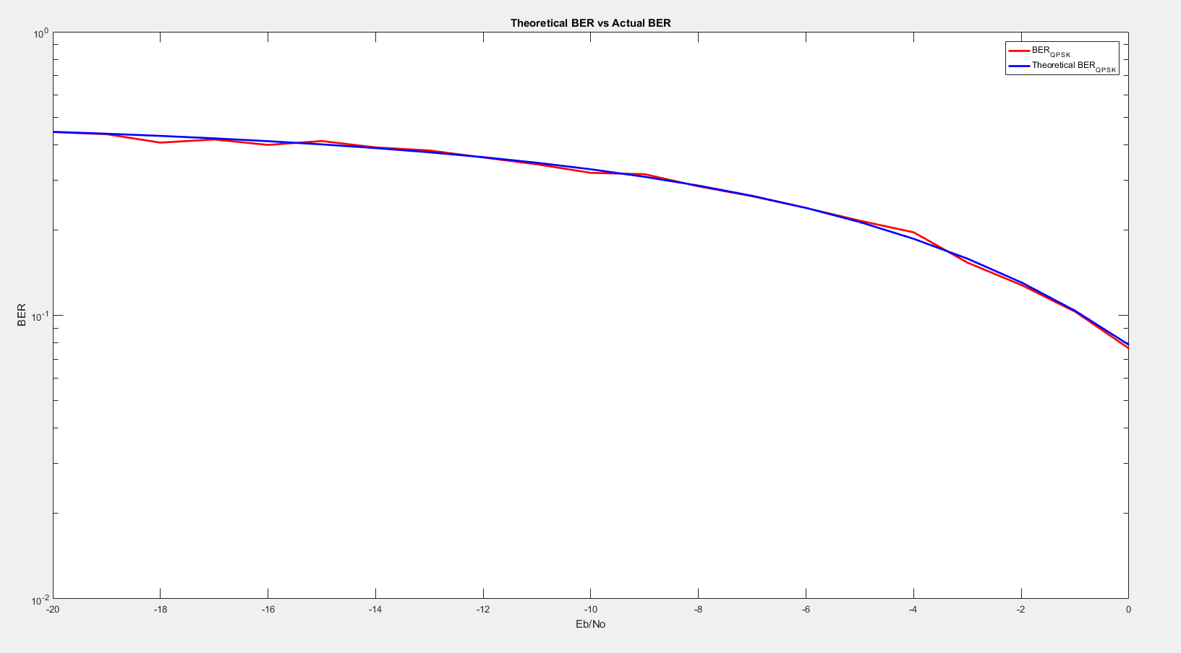

# Full MIMO chain with encoder:

